Week 6
5. ReactJS-HOL
Steps :-
CohortDetails.module.css :-
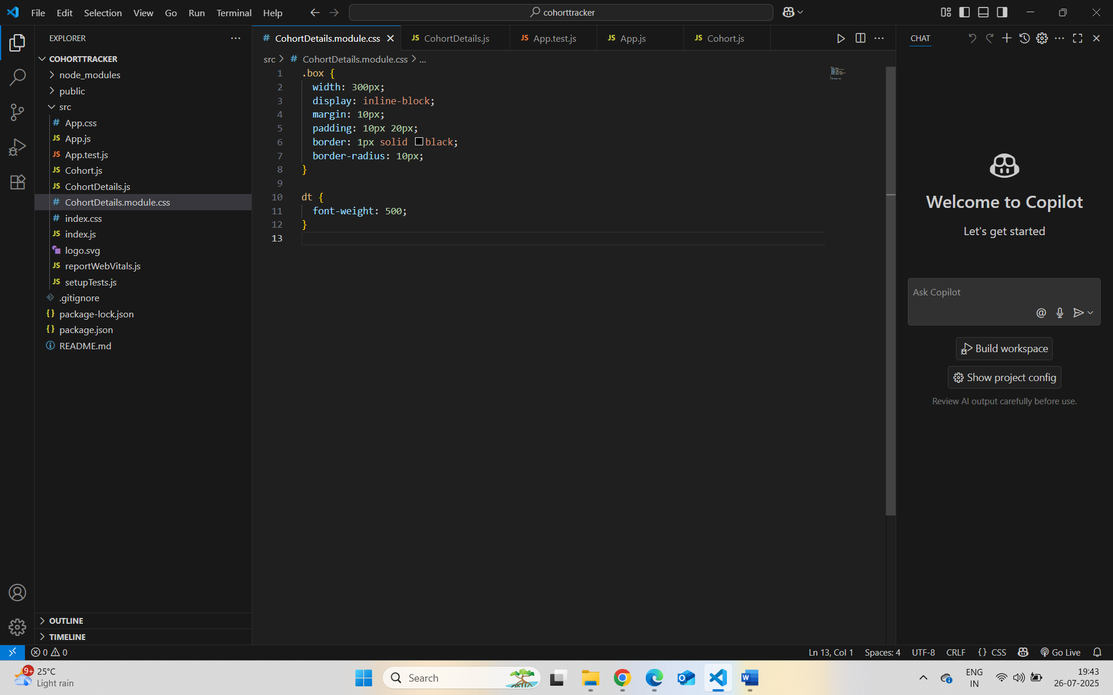
CohortDetails.js
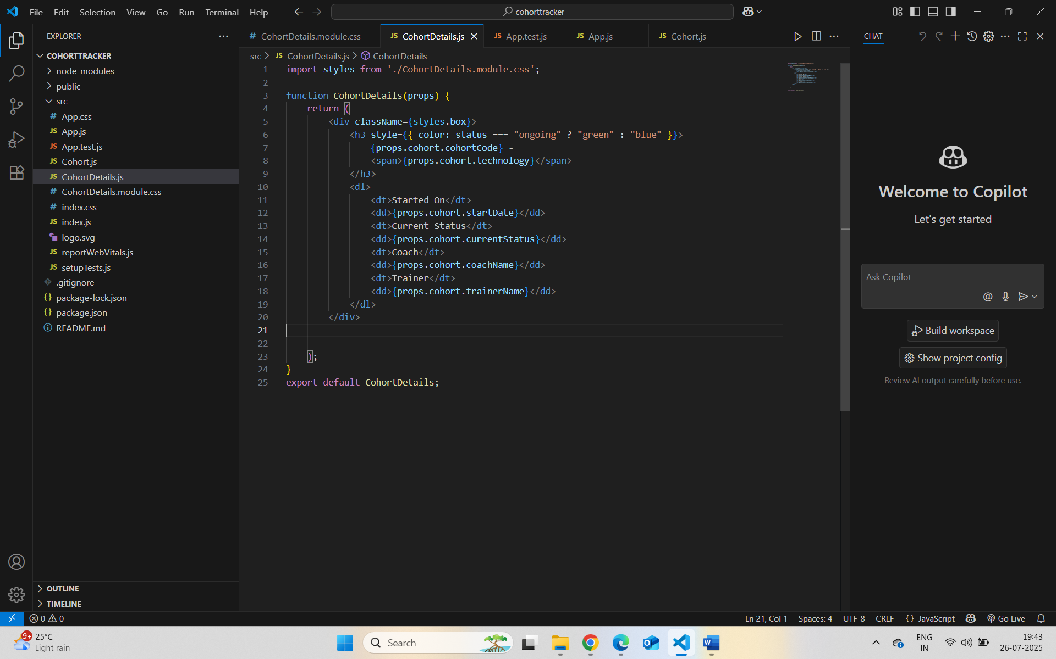

Localhost:3000 :-
